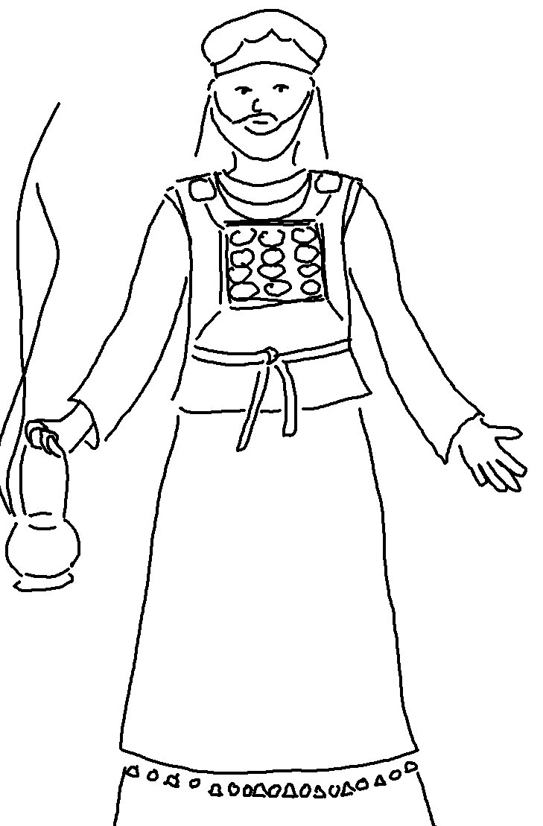
There is a way that seems _ _ _ _ _ to a man but in the end it leads to _ _ _ _ _.
Proverbs 14:12

